Lab 8: Latching Circuits, Advanced Logic, and Sensors

Worksheet
- Sorting Packages
- Insert a picture of your completed circuit on the LearnLine bench.
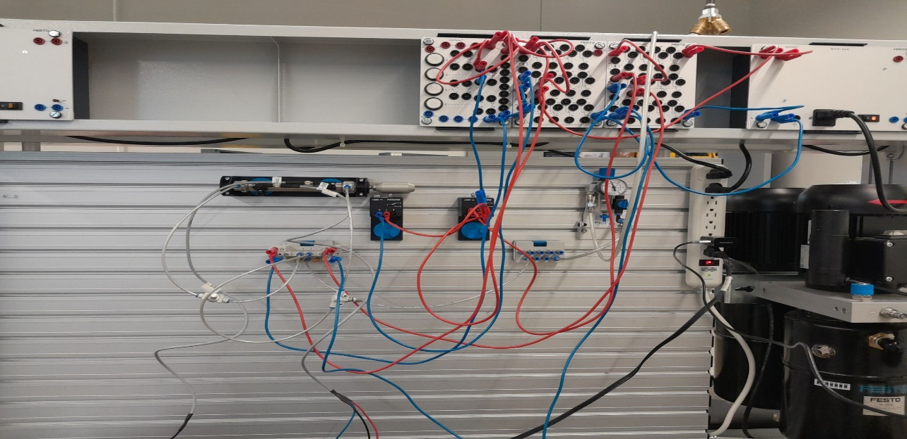

- Include a screensnip of your pneumatic circuit here.
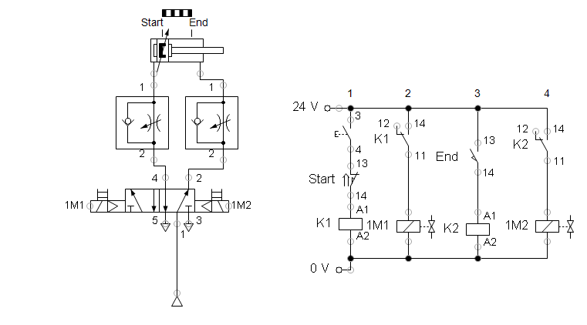

- Describe the working sequence of the control system.
The control system accepts a keypress from a momentary electric pushbutton. In conjunction with this, an active signal from the limit switch roller detector is required to activate the relay that extends the piston. Once the piston is in the extended position, it activates the second limit switch which sends the retract command through the relay and retracts the piston.
- How is an AND operation achieved in electrical circuits? How is an OR operation achieved?
An AND operation is achieved by wiring the circuits in series, and an OR operation is achieved by wiring the circuit in parallel. The series is to mean that a current must flow through both contacts in order to complete the signal to the relay, and the parallel to mean that a current can bypass one or the other contacts and signal the relay either independently or as a pair.
- Diverting Bottles
- Insert a picture of your completed circuit on the LearnLine bench.
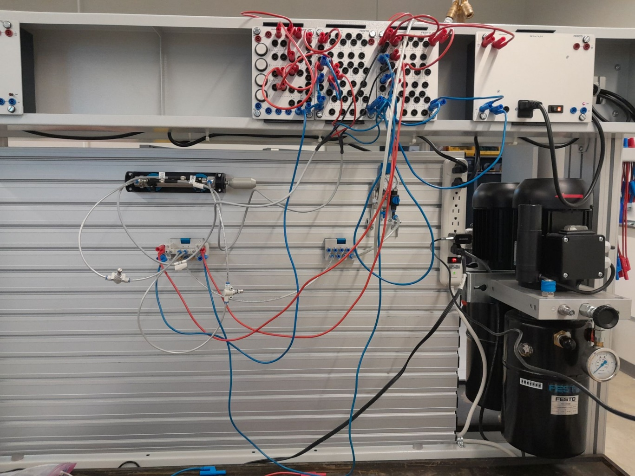

- Include a screensnip of your pneumatic circuit here.
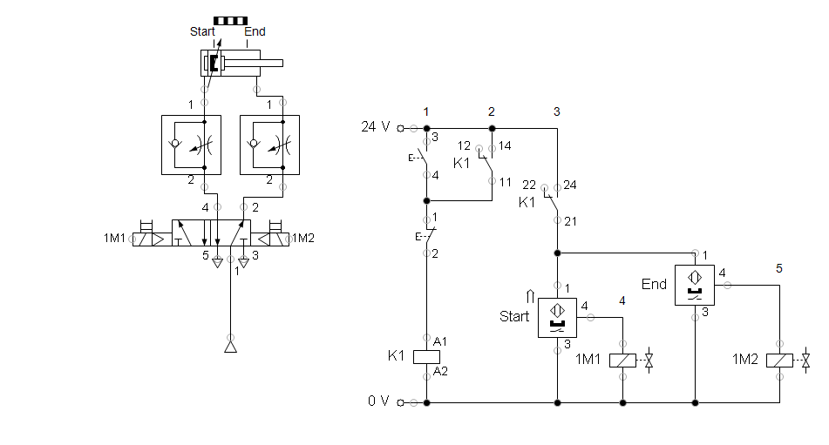

- Describe the working sequence of the control system.
The pushbutton activates a relay which when active sends power to the two magnetic proximity sensors. When one or the other becomes active, the one that is active will send an active signal to one of the directional pneumatic control solenoid valves. In the condition that the active signal is coming from the sensor in the retracted position, the piston will be extended, and in the condition that the active signal is coming from a sensor in the extended position, the piston will be retracted.
- Described how signal storage is implemented in the power section or the signal control section.
Signal storage works in the form of a latching circuit. The latching circuit takes an initial activation of the top pushbutton to activate the latch, and a second activation of the lower pushbutton to deactivate the latch. The latch is active continuously as long as the relay is active, and while the relay is active the magnetic proximity sensors are receiving power and ready to signal firing the directional control valve one way or the other.
- Describe the operation of a magnetic proximity switch (electrical).
A magnetic proximity switch has three ports. One port receives power, one acts a ground, and the third is active when the magnetic proximity sensor is triggered. The triggering happens when the sensor detects a ferrous or otherwise magnetic object within its range, and mechanically completes a circuit to activate the third port.
- Loading Roof Tiles
- Insert a picture of your completed circuit on the LearnLine bench.
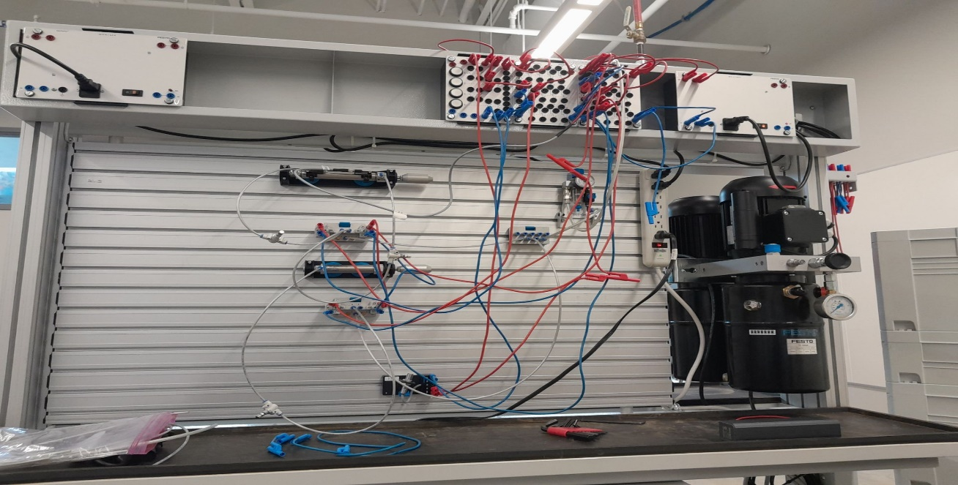

- Include a screensnip of your pneumatic circuit here.
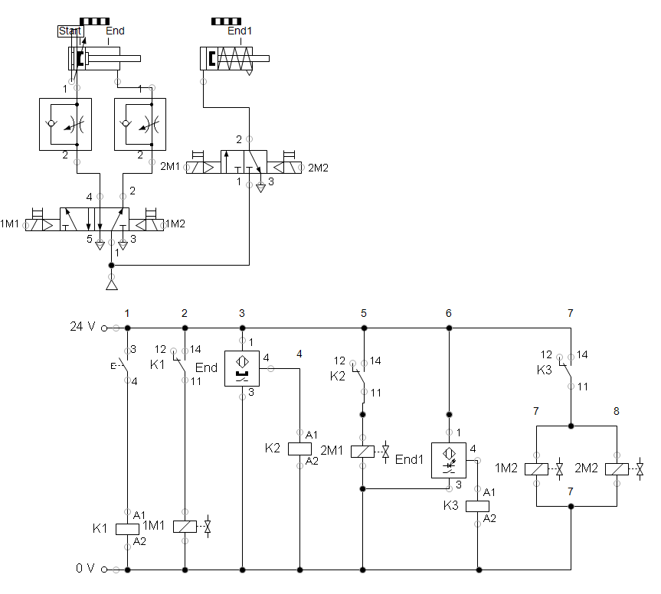

- Describe the working sequence of the control system.
When the pushbutton is pressed, the lower single cylinder extends at some slowed speed until it reaches its full extension. At that point, an optical sensor is triggered, and the double acting cylinder is sent to the extended position. Once the magnetic proximity sensor is tripped, as it is connected to the double acting cylinder in the extended position, it will send a signal to a relay in series with the signal from the optical sensor and activate the return signal. This signal is sent to both the 5/2 way valve running the double acting cylinder and the valve controlling the single acting cylinder to return them both to the home positions at the same speed and at the same time.
- When would you use an optical sensor instead of a mechanical roller switch?
An optical sensor will not accumulate so much wear over time as a mechanical roller switch as there are no moving parts to wear nor is there risk of parts shifting and physically damaging the sensor should they come into contact with it. The optical sensor will both outlast and outperform the roller switch provided it is used properly.
When finished and AFTER your lab has been verified, be sure to place your completed Worksheet in the Dropbox. Neatly clean up your workstation, put away all components in the Systainer, put all tools, and return the Systainer to the proper stack and location in the storage room corresponding to your group and kit number. Return chairs to their proper location, pushed in, and remove any trash from your station. If you have questions how something should be put away, please ASK. Do not leave until your station has been verified.

