Lab 2: Fundamental Logic and H-Bridge Motor Control

Worksheet By Todd Johns, Dolan Stapleton, and Kyle Bennett

Forward Motor Control
- Include your ladder logic to turn on the motor when the pushbutton is held below using the Snipping Tool to clip your rungs.
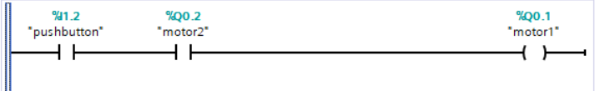

- Include your ladder logic to turn off the motor when the pushbutton is held below using the Snipping Tool to clip your rungs.
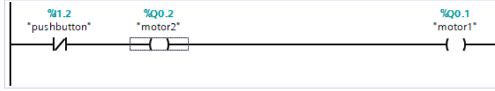

- Include your ladder logic to turn on the motor when the pushbutton is held and the optical sensor is activated below using the Snipping Tool to clip your rungs.\
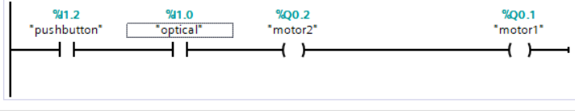

- What do you see wrong with this logic? What is wrong with this logic is that the optical sensor is only tripped once at the beginning when the puck goes through it after that it is never tripped again making the conveyor stop after the puck goes through the sensor.

Latching Circuit for Motor Control
- Include your ladder logic using the seal-in circuit to retain the state of the motor when the pushbutton and optical sensor are activated below using the Snipping Tool to clip your rungs.
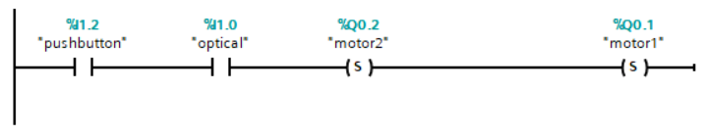

Motor Control with Logic
- Include your ladder logic demonstrating an AND gate below using the Snipping Tool to clip your rungs.
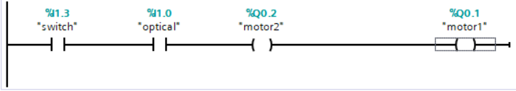

- Include your ladder logic demonstrating AND and OR gates below using the Snipping Tool to clip your rungs.
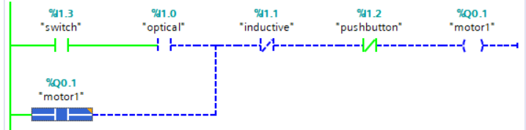

Multiple Control Panels
- Demonstrate your 3-panel motor control circuit to the Instructor. Include your ladder logic below using the Snipping Tool to clip your rungs.
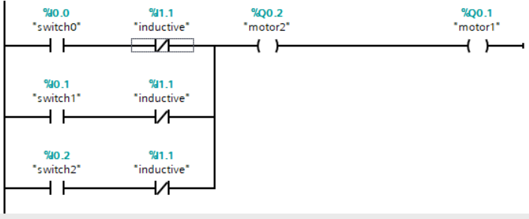

Reverse Motor Control
- Include below your ladder logic demonstrating forward and reverse operation of the conveyor motor using the Snipping Tool to clip your rungs.
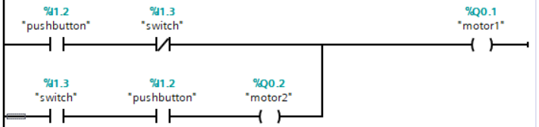

Toggling Powered State
- Include below your ladder logic demonstrating forward and reverse operation of the conveyor motor with toggle logic using the Snipping Tool to clip your rungs.
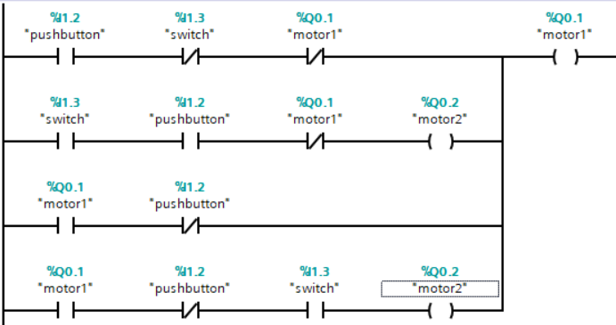

CHALLENGE
- For completion, demonstrate your Challenge code to the Instructor. Include your Challenge code below using the Snipping Tool.
