Lab 4: Data Manipulation in RSLogix 500

Worksheet

Working with Memory
- On the worksheet, provide screen snips showing the binary file data in decimal and binary format, showing that they do indeed correspond.
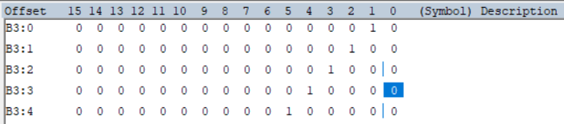

Move (MOV)
- Insert a screensnip of your MOV code into the worksheet.
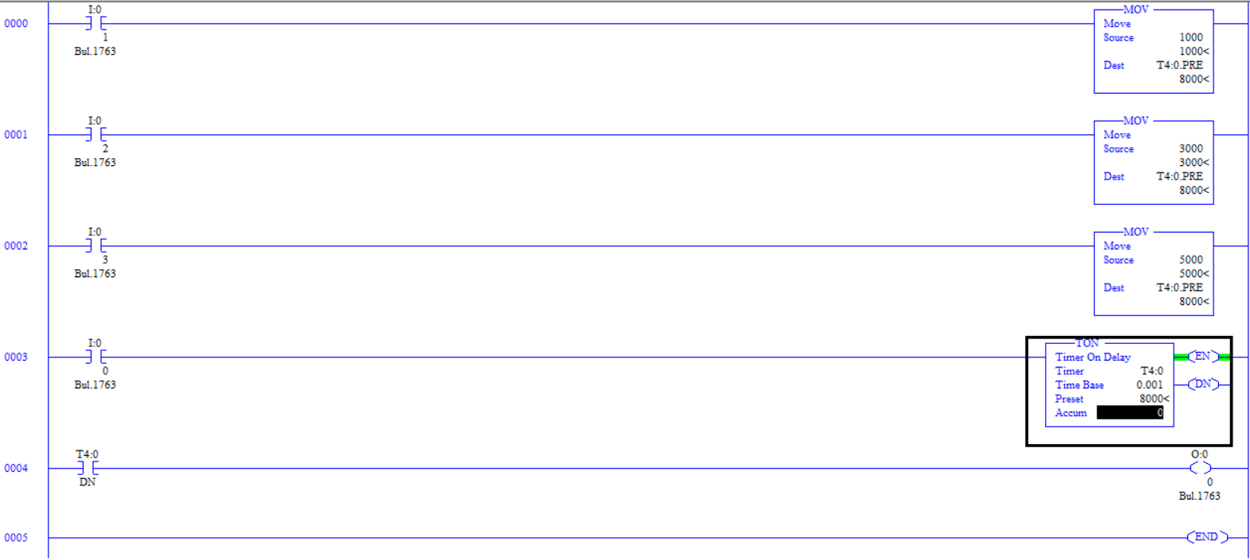

- How does the behavior of the program change when one of the MOV instructions is activated? When one of the MOV instructions is activated, it makes a copy of the value inputted in the source and moves it to the inputted destination which in this case is the timers preset

- What happens to the timer’s preset value when more than one MOV instruction rung is true? When multiple MOV commands are activated at once it tries to move each instructions source value into the move’s commands destination in this case the timer preset and that then glitches out as multiple values are trying to go to one location

- What do you observe when using binary elements to store the desired timer presets? Why? They are stored as binary in the move command but once they are moved to the timer preset, they change to decimal so the timer has a preset value that it can display while running

Move with Mask (MVM)
- Insert a screensnip of your MVM demonstration code below.\
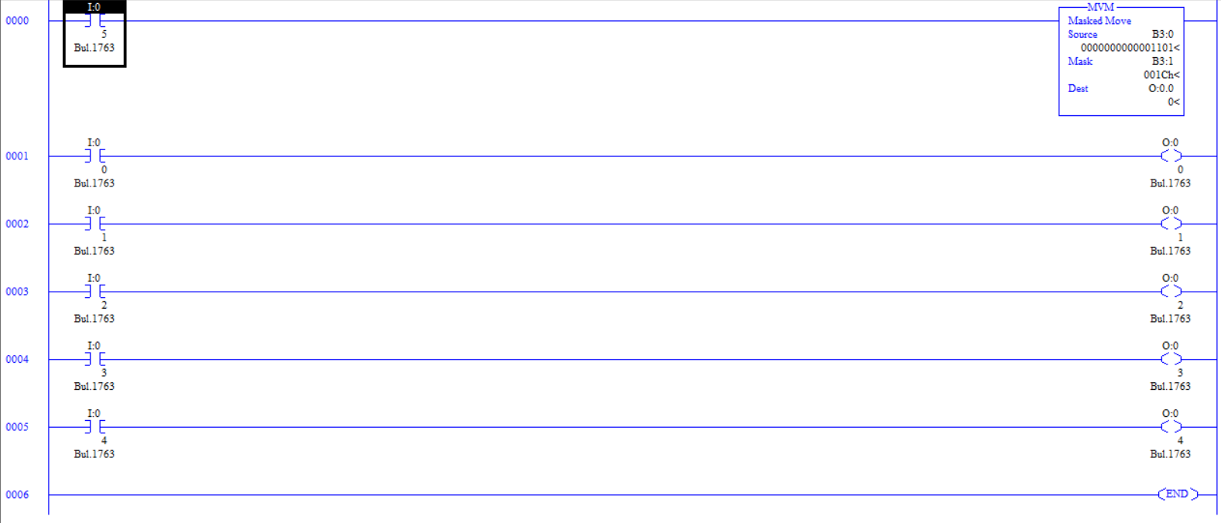

- What do you notice about the mask value? The mask value is in hexadecimal

- What do you notice about outputs O0.0/2 and O0.0/3? Why does this occur? Outputs O0.0/2 and O0.0/3 are turning on and off because the mask is allowing them to pass through it. The mask converted to binary is 11100 so it only allows O0.0/2 – O0.0/4 to pass through as long as their value is 1

- Give a practical example of how the MVM can be used, in which the MOV instruction would be inappropriate or could cause errors. If you want to be able to block out specific parts of an inputted value and then be able to change the mask so you can get a different outcome using the same inputted value. MVM would not be able to be used if you need the exact value you input in your program.

Bitwise Word Manipulations (AND, OR, XOR, CLR)
- Insert a screensnip of your AND demonstration code below.
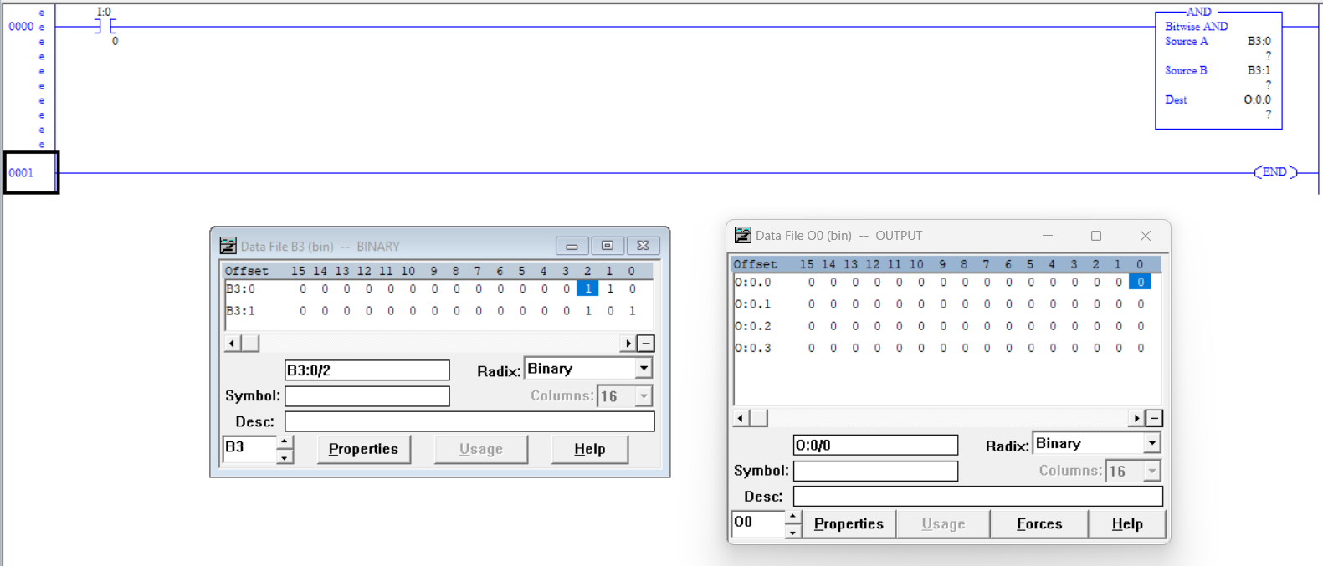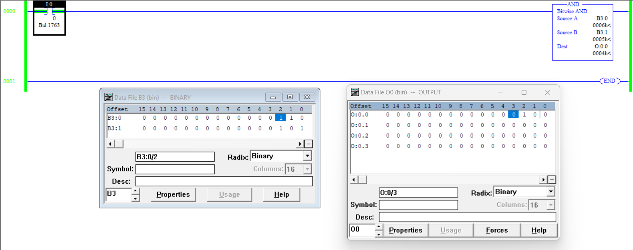

- Insert a screensnip of your OR demonstration code below.
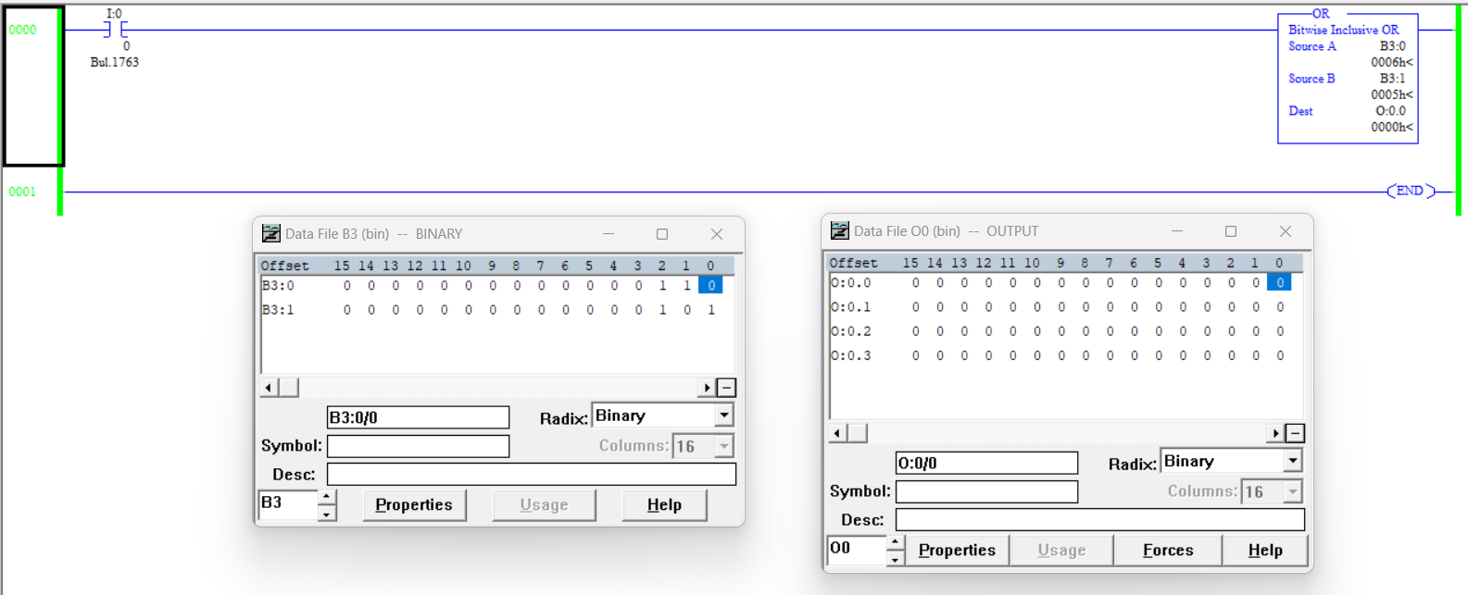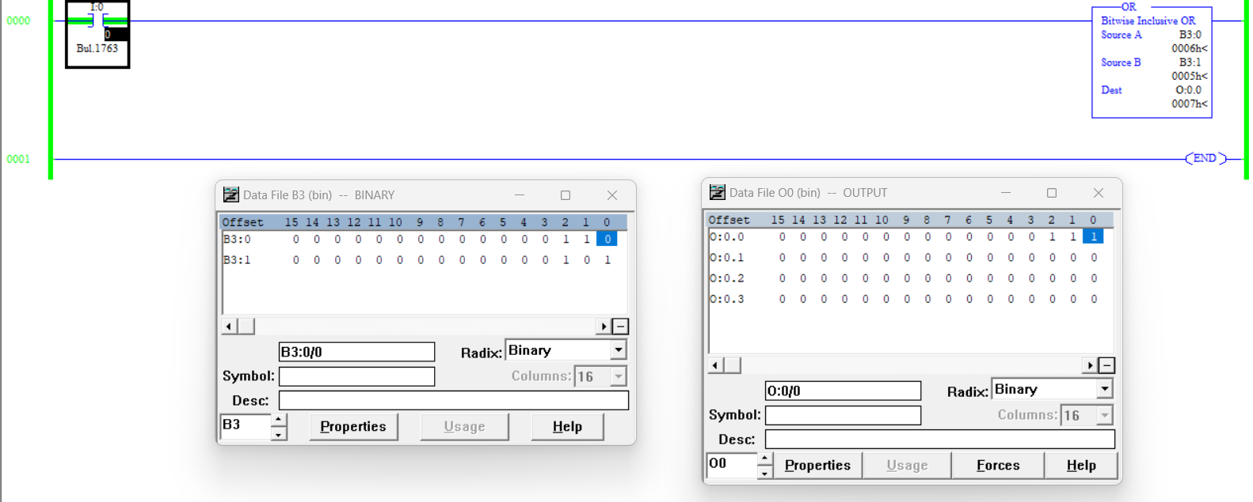

- Insert a screensnip of your XOR demonstration code below.
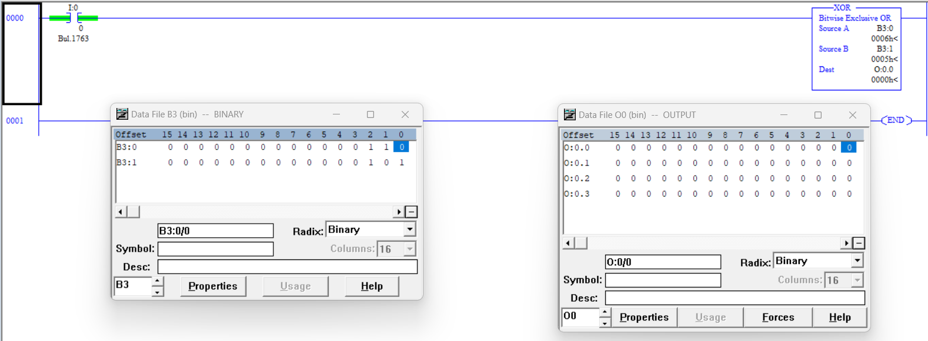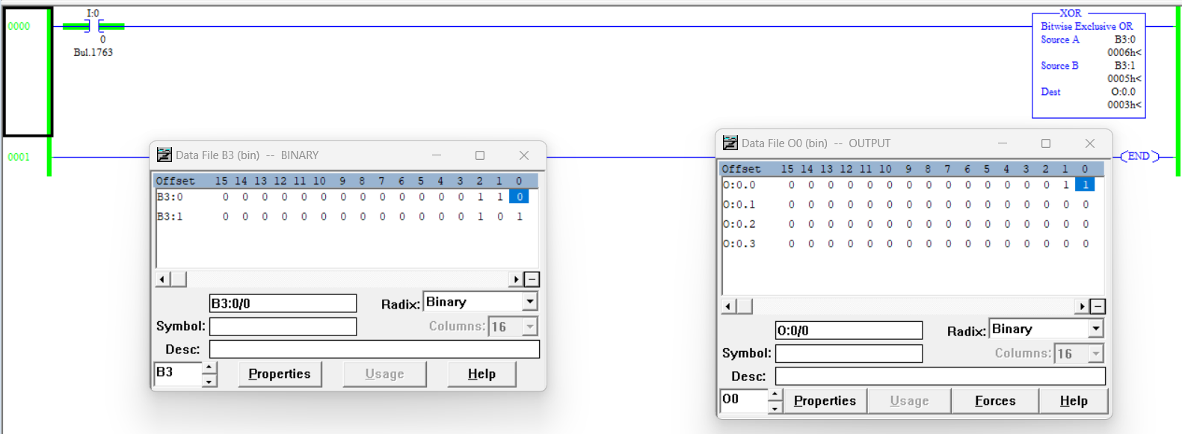

- Insert a screensnip of your CLR demonstration code below.
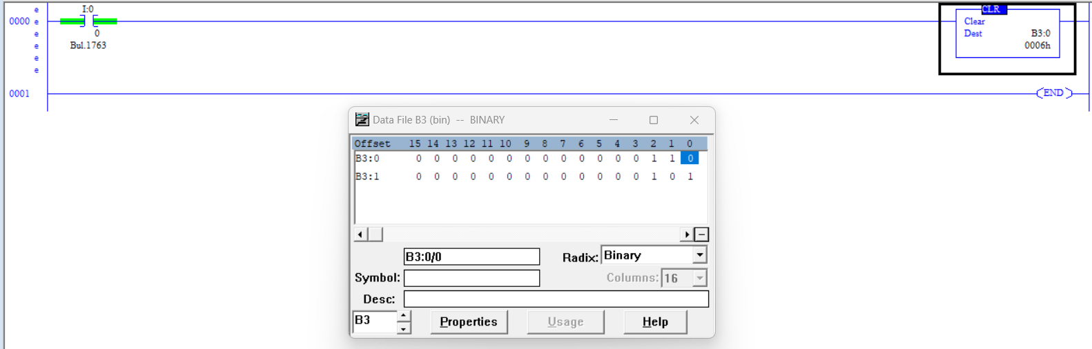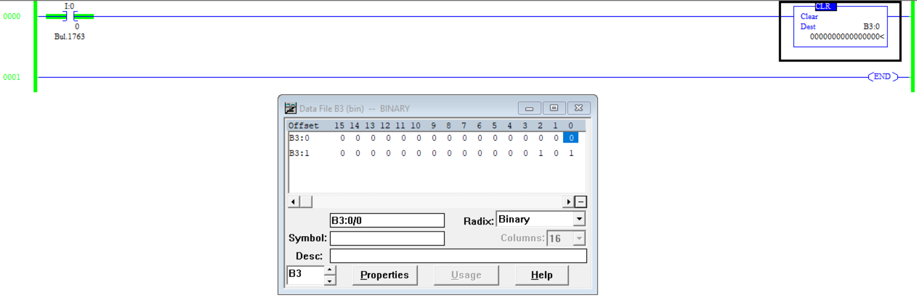

- Discuss any observations regarding these operations. When the CLR instruction is activated, it clears the inputted value in the destination

File Copy (COP) and File Fill (FLL)
- Insert a screensnip of your FLL demonstration code below.
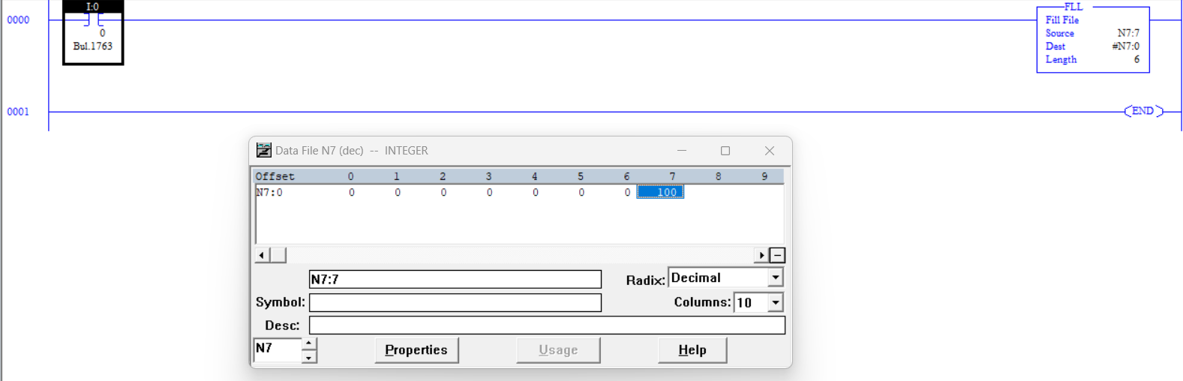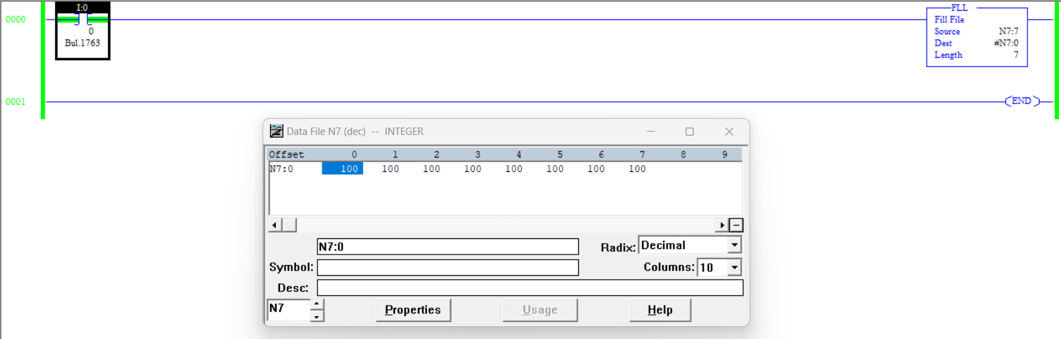

- Insert a screensnip of your COP demonstration code below.
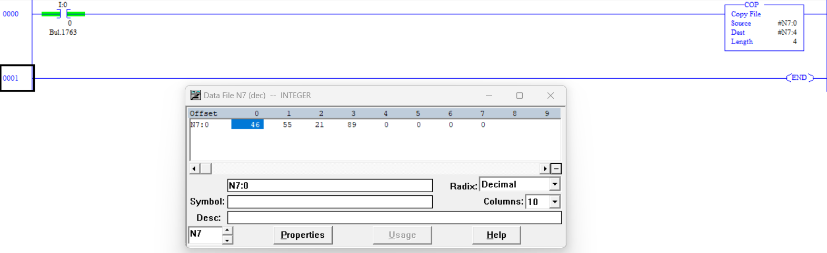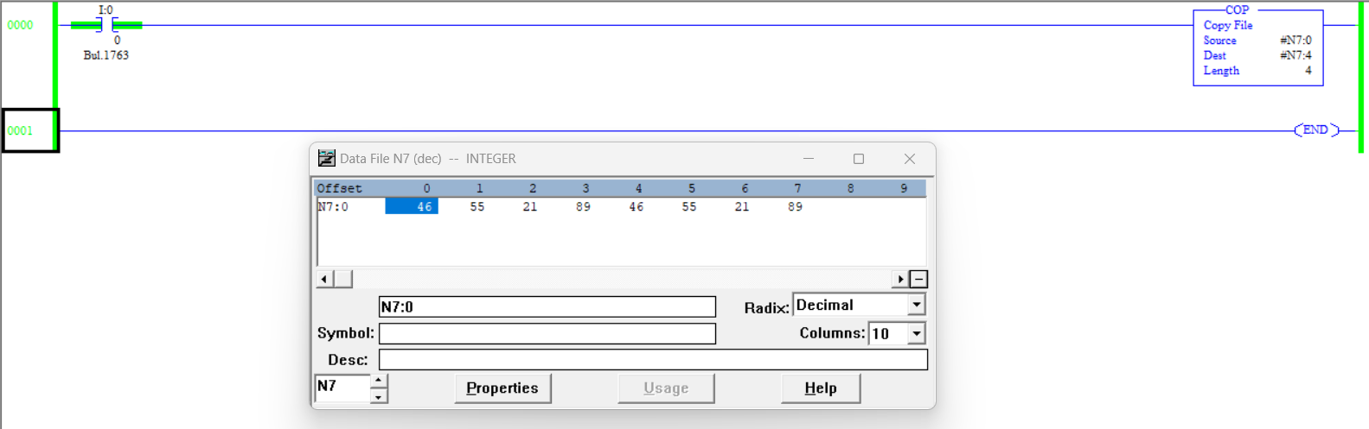

CHALLENGE: Traffic Light
- Include a screensnip of your traffic light program using only one timer below. Upload all of your project files and your Worksheet to the Dropbox for future reference.