Lab 6: Introduction to Electropneumatics with S7-1200

Worksheet by Todd Johns, Dolan Stapleton, and Kyle Bennett

Controlling the Single-Acting Cylinder
- Take a picture of your normally-closed single-acting cylinder control circuit and include it below.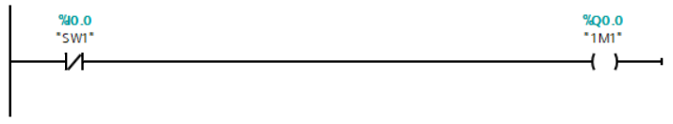

- Insert a screenshot of your Tag Table below showing the tags “SW1” and “1M1”.
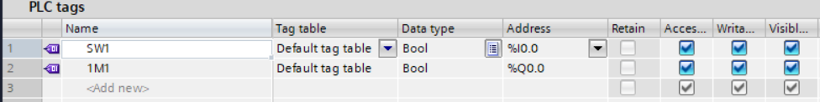
- Take a picture of your normally-open single-acting cylinder control circuit and include it below.
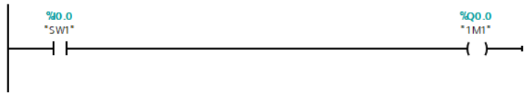
- How does this change affect the behavior of your PLC program? It inverted the action of the single action piston making the piston stay retracted when off and extended when on.

Controlling the Double-Acting Cylinder
- Include a screensnip of your PLC code below.
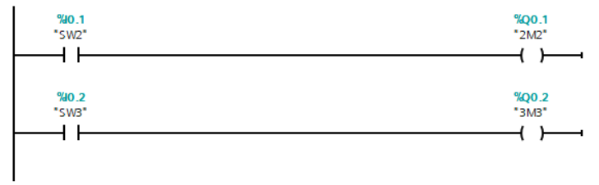

CHALLENGE: Timer Operations
Demonstrate your code for the instructor.
- Include a screensnip of your PLC code below.
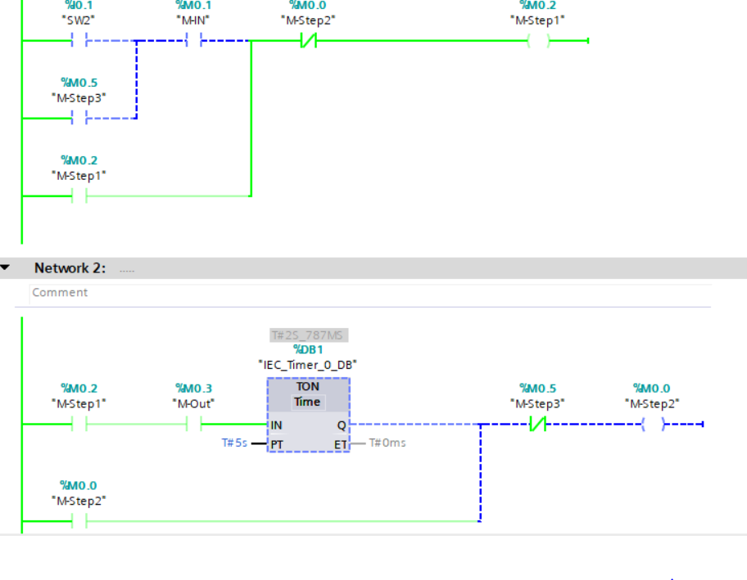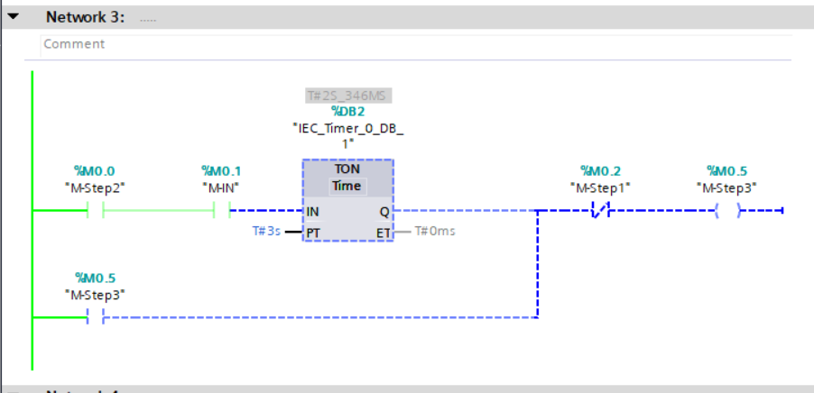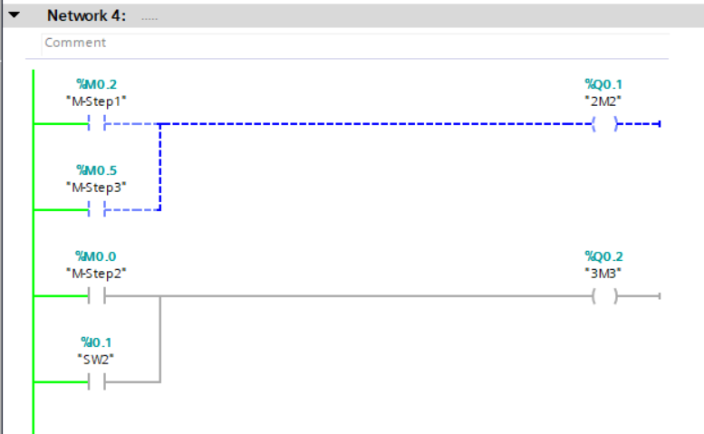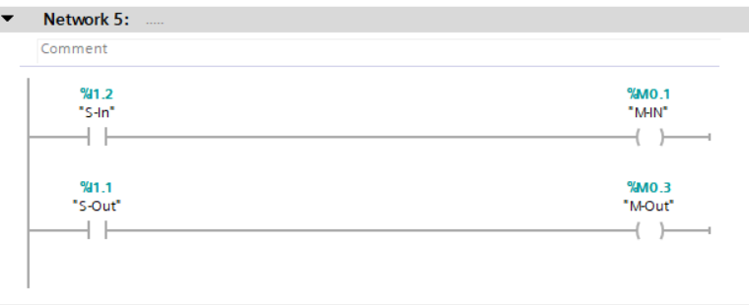

CHALLENGE: Counter Operations
Demonstrate your code for the instructor before cleaning up.
- Include a screensnip of your PLC code below.
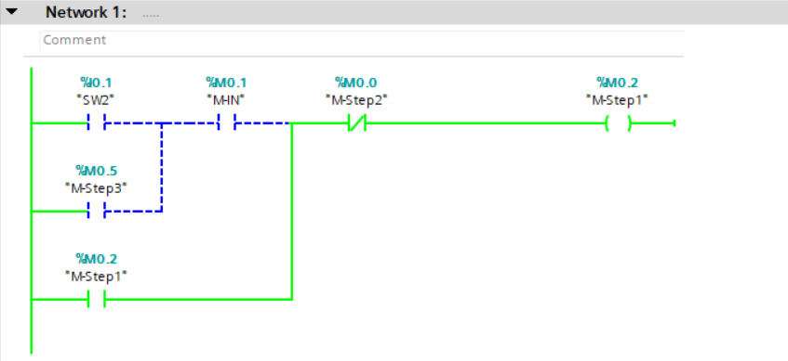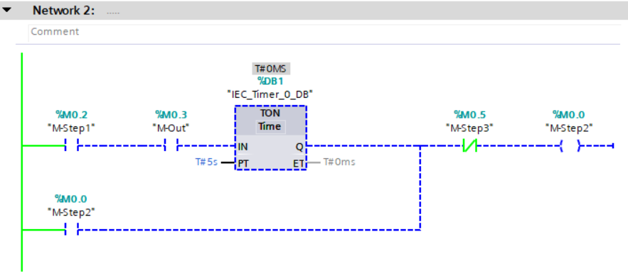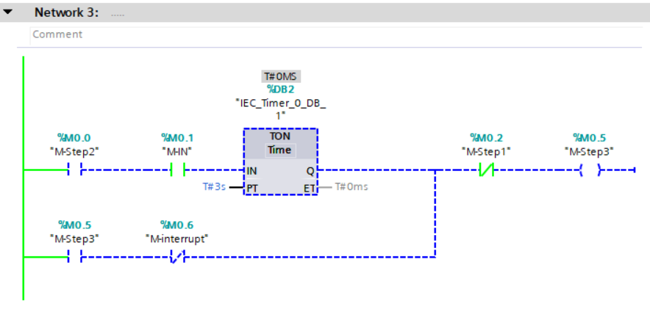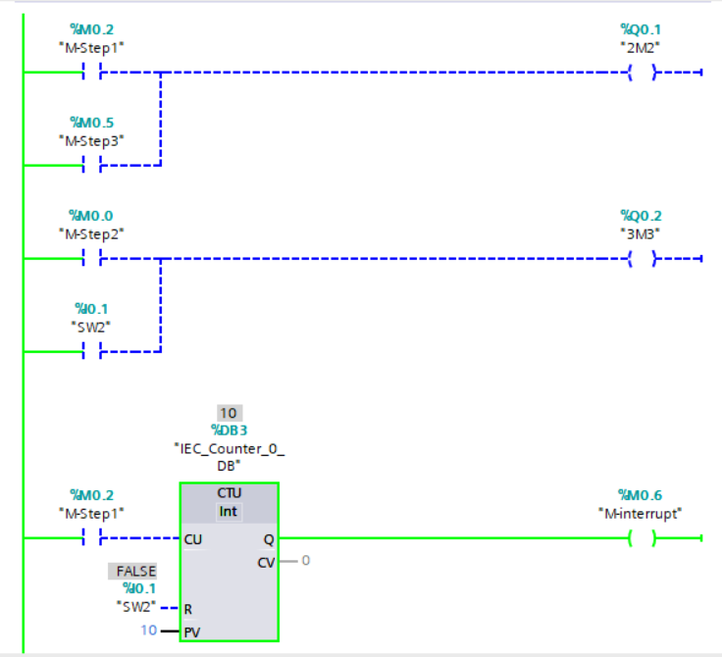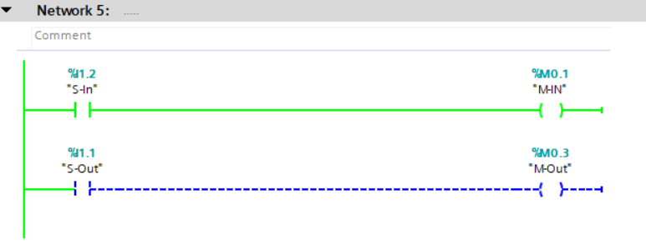

When finished and AFTER your lab has been verified, be sure to place your completed Worksheet in the Dropbox. Neatly clean up your workstation, put away all components in the appropriate Systainers, put all PLC components back in the box, and return the Systainers to the proper stack. You may put your PLC in the clear tote or in the top drawer of your workstation. Put the clear tote back in its space corresponding to your group and kit number. You SHOULD remove the IEEE-488 harness from the PLC, as you will not need it in the following lab.

