Lab 5: Output Sequencers

Worksheet

Event-Driven Sequencer Output (SQO)
- Describe the behavior of the program. What happens when the end of the positions is exceeded? Every time the “Pushbutton” is pressed it increments the sequencer output and it outputs the inputted value that corresponds to the position the sequencer is on. Once the sequencer reaches its end position on the next activation it goes right back to its first position.

- Provide a screenshot of your program. Also, upload your code to the Dropbox (as an RSLogix project).
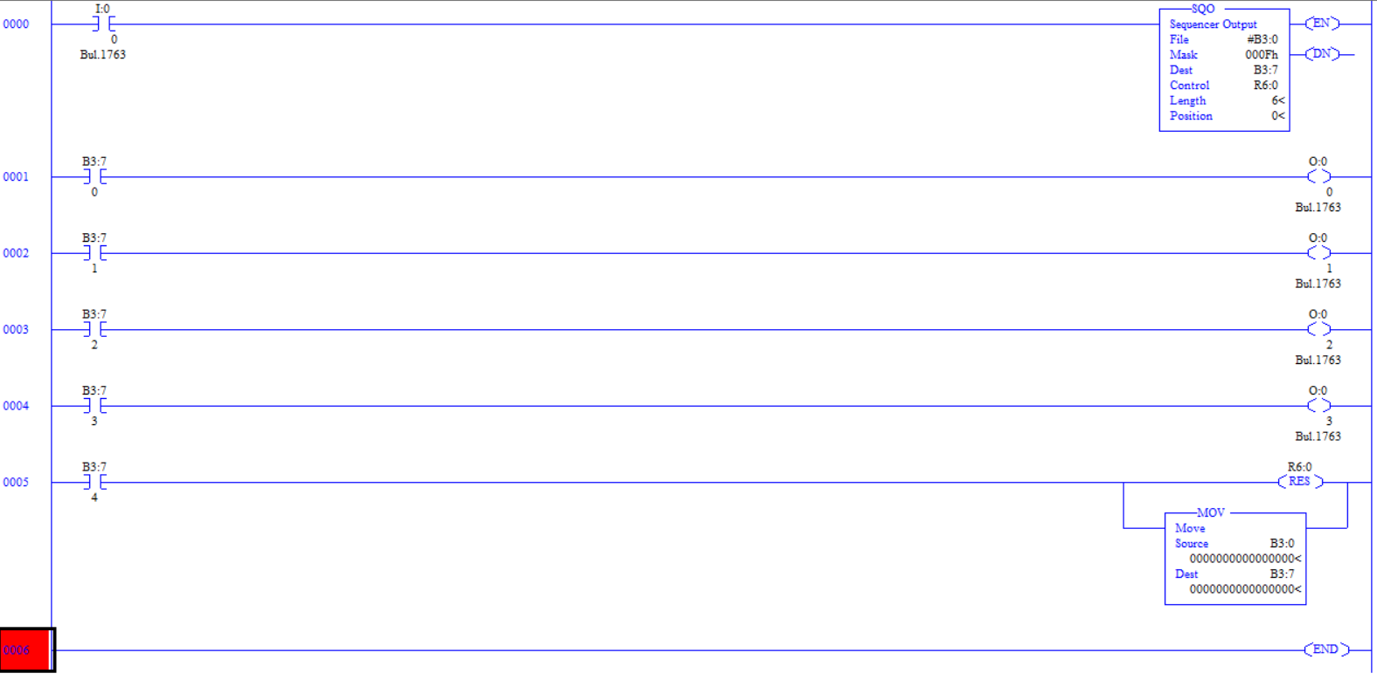

Time-Driven Sequencer Output (SQO)
- Provide a screenshot of your program. Also, upload your code to the Dropbox (as an RSLogix project).
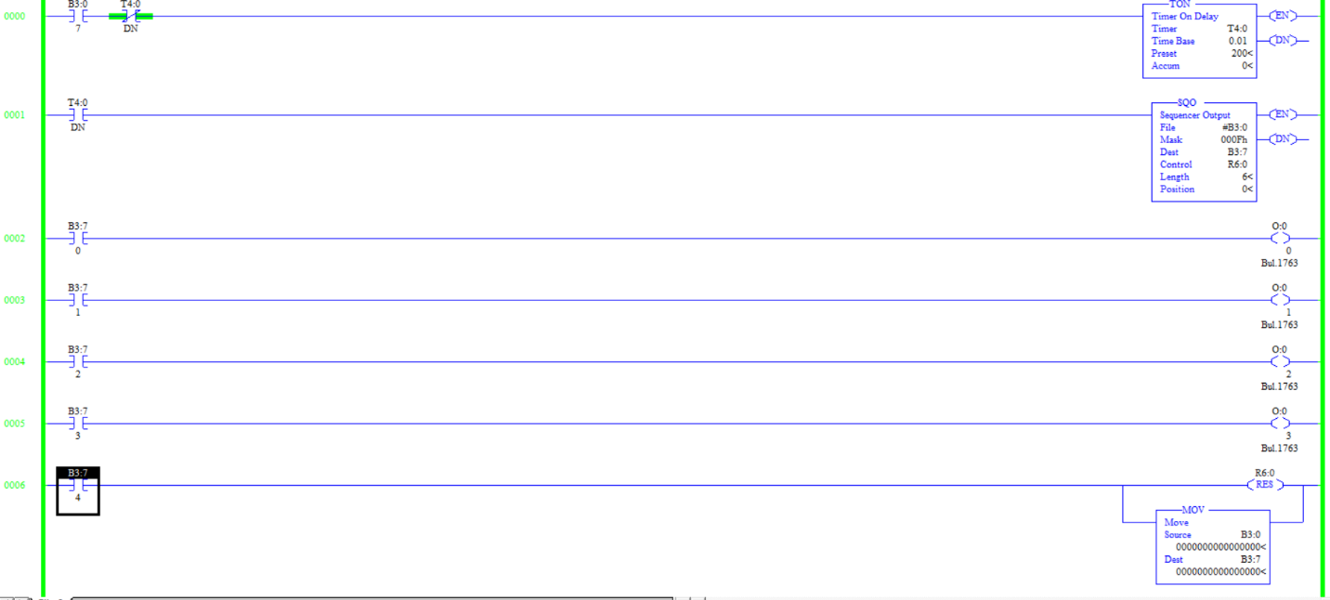

Sequencer Compare (SQC)
- What do you notice about the behavior of the SQC instruction? Describe its operation and any strengths and weaknesses you may observe. The SQC operates as you cycle the sequencer through each of its positions it compares each stored value to another set of input data to see if they match. If a match is found the sequencer, then turns on its bit found coil. A strength that I observed is that it can help quickly find a match between two sets of data. A weakness I noticed is that the sets of data the sequencer can handle can’t be too complex in how they match.

Challenge: Traffic Light
- Provide a screenshot of your program. Also, upload your code to the Dropbox (as an RSLogix project).
